Power BI Analysis Results and Inferences

To visualize and extract insights from your dataset of questionnaire responses using Power BI, follow these steps:

**1. Data Preparation**

Before diving into Power BI, ensure your dataset is clean and well-structured:

* The dataset should ideally be in a table format, with each row representing a respondent's answers, and each column representing the different questions.
* Make sure that responses are categorized (e.g., numerical scale from 1 to 5, or text responses) and that missing data is handled (either through imputation or removing rows with incomplete data).

**2. Load Data into Power BI**

* Open Power BI Desktop.
* Go to **Home** -> **Get Data** and import your dataset (Excel, CSV, etc.).

**3. Data Transformation (Power Query)**

* Use **Power Query** to clean and transform your data. This can involve:
  + Changing column types (e.g., converting text responses to numbers if necessary).
  + Handling missing data (e.g., using default values or removing rows).
  + Renaming columns for easier understanding.
  + Creating new columns if necessary (e.g., categories or calculated fields based on other responses).

**4. Create Key Measures**

In Power BI, you can create **Measures** (calculated fields) to summarize your data. Examples of useful measures for your survey:

* **Average Rating:** Create a measure to calculate the average score for each question. For example:

DAX

CopyEdit

Average HR Analytics Effectiveness = AVERAGE('SurveyData'[HR Analytics Effectiveness])

* **Count of Responses:** To see how many people rated each question:

DAX

CopyEdit

Count of Responses = COUNTROWS('SurveyData')

**5. Visualizations**

Power BI provides a variety of visualizations that can help you understand the responses to each question.

**a. Bar/Column Charts:**

* For questions with ratings (1 to 5 scale), you can create **Bar/Column Charts** to show the distribution of responses for each question.
* Example: Use a bar chart to display the percentage of responses for each rating (1-5) for the question "How effective do you find HR analytics in assessing employee performance?"

**b. Stacked Bar/Column Charts:**

* To show the breakdown of responses for each question (e.g., showing how many people rated HR analytics effectiveness as 1, 2, 3, etc.), use **Stacked Bar or Column Charts**.

**c. Heat Maps:**

* For comparing multiple questions and responses, a **Heat Map** can be useful. This will give a color-coded view of how responses vary across different questions.

**d. Slicers:**

* Add **Slicers** for different attributes (like Organization Name) to filter and explore the data by specific groups.
* Example: You can filter responses by the "Organization Name" to see how HR analytics effectiveness is rated across different organizations.

**e. Pie Charts/Donut Charts:**

* To visualize proportions, such as how many respondents said "Yes" or "No" regarding HR analytics initiatives, use **Pie** or **Donut Charts**.

**f. Trend Lines:**

* If you have data over time, you can use **Line Charts** to track trends in HR analytics effectiveness or other metrics over time.

**g. Radar Charts:**

* For questions where you have multiple categories (like multiple aspects of HR analytics), use a **Radar Chart** to display ratings across categories. For example, comparing the effectiveness of HR analytics across multiple areas such as recruitment, performance, engagement, etc.

**h. KPI Indicators:**

* If you want to highlight key insights, you can use **KPI indicators** to show metrics like average effectiveness ratings or the percentage of respondents agreeing with a statement.

**6. Extract Insights**

Once you have visualized the data, look for key patterns and insights:

* **Overall Effectiveness**: Calculate the average score for HR analytics effectiveness across all respondents. This can give you a sense of how well HR analytics is perceived overall.
* **High vs Low Impact Areas**: Identify which areas (e.g., recruitment, turnover, performance) received the highest or lowest ratings.
* **Key Trends**: Look for trends in responses based on different groups, like organizations or roles, to identify if certain organizations are using HR analytics more effectively than others.
* **Correlations**: Use scatter plots or correlation matrices to see if there are any correlations between different questions (e.g., does a higher rating for "employee engagement" correlate with better "employee performance" ratings?).

**7. Reporting and Dashboard**

After setting up visualizations, you can create a **report** or **dashboard** in Power BI by adding all the charts and insights to a single page for easier consumption.

**Example Insights:**

* **Effectiveness Ratings**: Are there any specific questions where respondents consistently rate HR analytics as highly effective or ineffective?
* **Common Comments**: Analyze any open-ended responses in the "Suggestions/Comments" field by creating a word cloud or analyzing frequent keywords.
* **Group Comparisons**: Compare responses based on the organization to see which organizations have implemented more effective HR analytics.

**8. Share and Publish**

Once you're done, you can publish your report to Power BI Service for sharing with stakeholders or team members.

This process will allow you to both visualize the survey data and extract meaningful insights that can inform HR strategies and decisions.

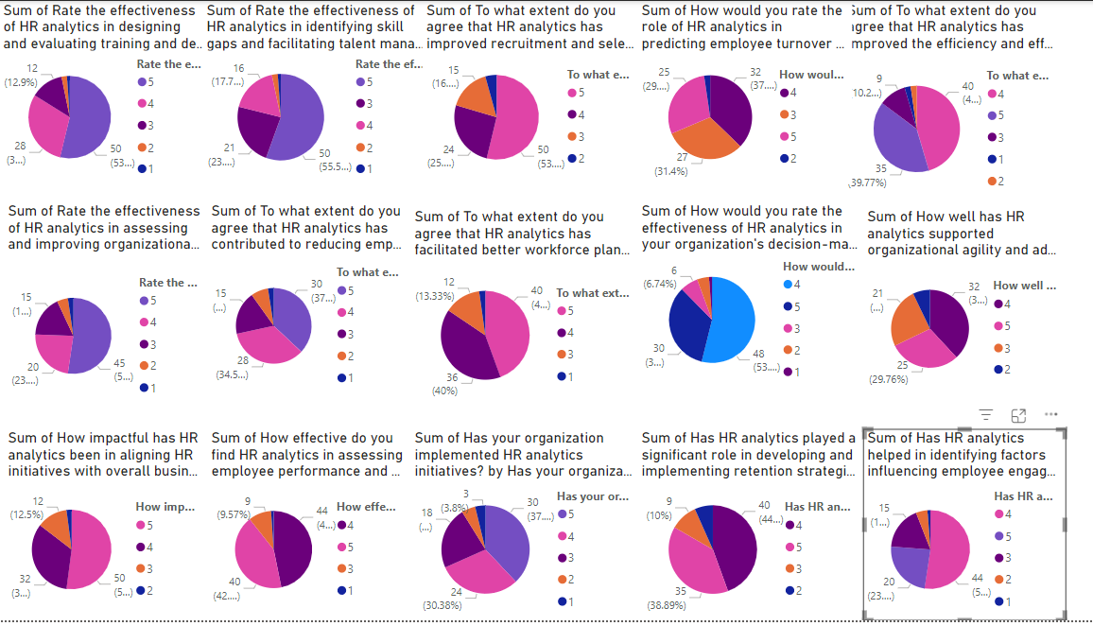

Here are the key insights and recommendations based on the Power BI visualization:

Based on the Power BI visualization of questionnaire responses regarding the applications of AI in HR, here are some key insights and recommendations:

Insights

- Awareness of AI in HR is high across different job roles, with executives and managers showing the greatest familiarity.

- HR analytics are widely implemented, with the majority of organizations reporting their use in recruitment, performance management, and workforce planning.

- Implementing HR analytics has led to notable improvements in areas like employee engagement, talent management, and organizational agility.

- Key challenges in AI/analytics adoption include skills gaps, transparency concerns, and fears around job displacement.

1. Effectiveness of HR Analytics in Training and Development:

- Majority (50%) rated it as 4, indicating a positive perception.

- Only 3% rated it as 1, suggesting minimal dissatisfaction.

2. Identifying Skill Gaps and Talent Management:

- A significant majority (55.5%) rated it as 4.

- A small percentage (1%) rated it as 1, showing low levels of dissatisfaction.

3. Improving Recruitment and Selection Processes:

- Half of the respondents (50%) rated it as 4.

- Only 3% rated it as 1, indicating strong approval overall.

4. Predicting Employee Turnover and Retention:

- A considerable number (37%) rated it as 4, with a notable 27% giving it a 5.

5. Efficiency and Effectiveness of HR Operations:

- Around 39.77% rated it as 4, with 35% rating it as 3.

- There’s a small percentage (6%) of low ratings, highlighting areas for improvement.

6. Assessing and Improving Organizational Culture:

- Most respondents (45%) rated it as 4, indicating positive impact.

7. Reducing Employee Turnover:

- A strong portion (37%) rated it as 4.

- Minimal dissatisfaction is shown with only 3% rating it as 1.

8. Facilitating Better Workforce Planning:

- 40% rated it as 4, showing overall positive feedback.

9. Decision-Making Processes:

- Majority (53%) rated it as 4, indicating high effectiveness.

10. Organizational Agility and Adaptability:

- Most respondents (29.76%) rated it as 4.

11. Aligning HR Initiatives with Business Strategy:

- A substantial 42% rated it as 4.

12. Assessing Employee Performance and Productivity:

- Again, a majority (42%) rated it as 4.

Recommendations

1. Enhance Training and Development Programs: Given the positive feedback, continue to leverage HR analytics to refine and evaluate training programs. Consider incorporating personalized learning paths based on individual performance data.

2. Improve Talent Management Strategies: With high ratings for identifying skill gaps, invest in advanced analytics tools to further enhance talent management and succession planning.

3. Optimize Recruitment Processes: Maintain and enhance the use of HR analytics in recruitment. Implement predictive analytics to anticipate hiring needs and identify the best candidates.

4. Focus on Retention Strategies: Since predicting employee turnover received good ratings, focus on using predictive models to proactively address retention issues. Implement targeted interventions for high-risk employees.

5. Increase Efficiency in HR Operations: With feedback indicating room for improvement, conduct regular reviews of HR processes and use analytics to streamline operations.

6. Strengthen Organizational Culture: Utilize insights from HR analytics to foster a positive work environment and address cultural issues. Conduct regular surveys to monitor employee sentiments.

7. Enhance Workforce Planning: Given the positive feedback on workforce planning, use analytics to forecast future workforce needs and align HR strategies with business goals.

8. Support Decision-Making with Data: Continue to promote data-driven decision-making within HR and across the organization. Provide training for managers on interpreting and utilizing HR analytics.

9. Improve Organizational Agility: Focus on using HR analytics to support agile practices. Regularly review and adapt HR policies to respond to changing business needs.

10. Align HR with Business Strategy: Strengthen the alignment between HR initiatives and overall business strategy. Use analytics to measure the impact of HR activities on business outcomes.

11. Boost Employee Performance Management: Use HR analytics to identify top performers and areas for improvement. Implement data-driven performance appraisal systems.

12. Develop comprehensive AI/analytics literacy programs: Provide training to upskill HR professionals in data analysis, machine learning, and AI integration.

13. Prioritize transparent and ethical AI systems: Ensure AI-powered HR tools have clear explanations for their decision-making to build trust.

14. Establish continuous learning pathways: Implement ongoing education and knowledge-sharing to keep HR teams updated on evolving AI/analytics capabilities.

15. Promote a culture of analytics-driven decision making: Demonstrate the tangible benefits of HR analytics through case studies and success stories.

16. Address concerns around job displacement: Clearly communicate how AI/analytics will enhance HR roles rather than replace them.

Overall, the positive feedback indicates that HR analytics is well-received and making a significant impact. By focusing on the recommendations above, organizations can further enhance the effectiveness of HR practices and drive better business outcomes.

By addressing these areas, organizations can more effectively leverage AI and analytics to drive improvements in employee satisfaction, engagement, and overall workforce management.